Ramesh Babu Komma- Center For Negative Carbon Emissions
Pressure Drop measurement for MT 125-micron mesh bag in closed loop wind tunnel.
Set up image:
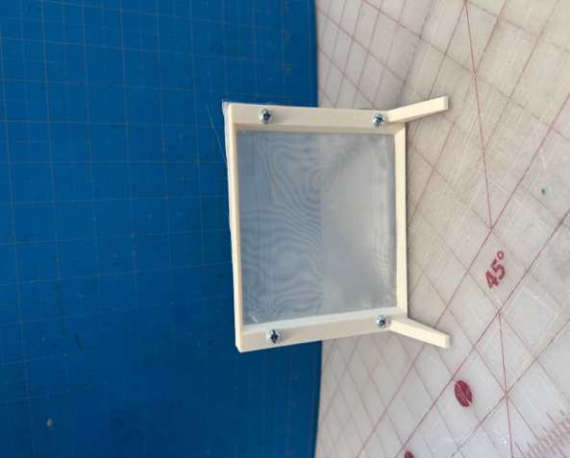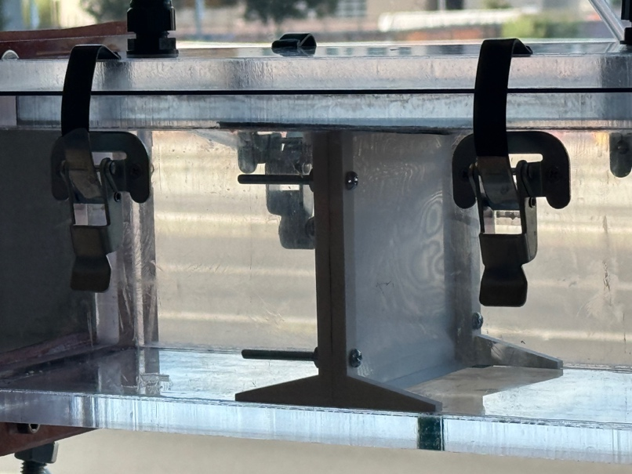

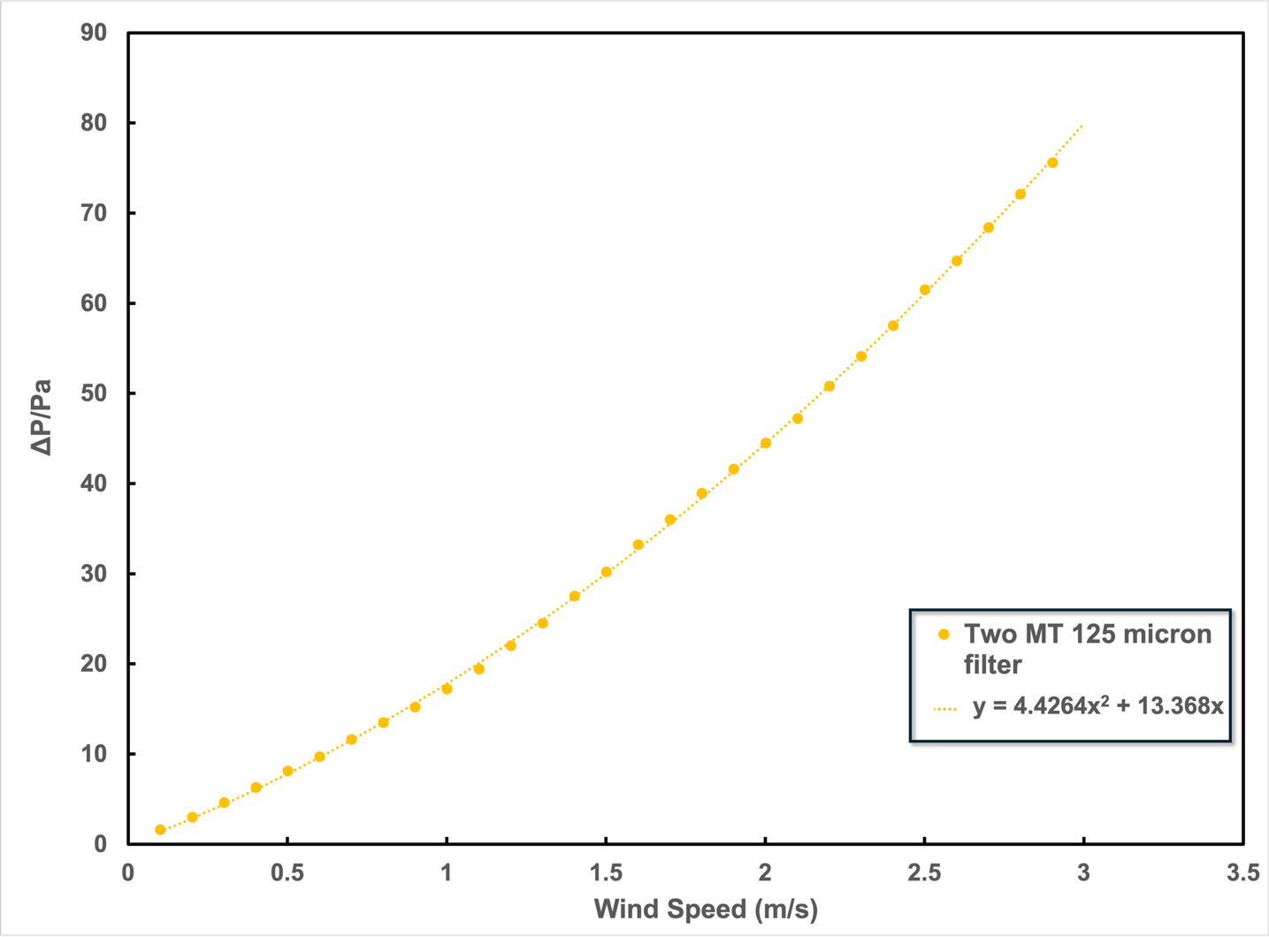

Wind Speed | Two MT 125 micron filter
0.1 | 1.6
0.2 | 3
0.3 | 4.6
0.4 | 6.3
0.5 | 8.1
0.6 | 9.7
0.7 | 11.6
0.8 | 13.5
0.9 | 15.2
1 | 17.2
1.1 | 19.4
1.2 | 22
1.3 | 24.5
1.4 | 27.5
1.5 | 30.2
1.6 | 33.2
1.7 | 36
1.8 | 38.9
1.9 | 41.6
2 | 44.5
2.1 | 47.2
2.2 | 50.8
2.3 | 54.1
2.4 | 57.5
2.5 | 61.5
2.6 | 64.7
2.7 | 68.4
2.8 | 72.1
2.9 | 75.6
3

